- Describe your Pet or your dream Pet.
It
Describing Sven.
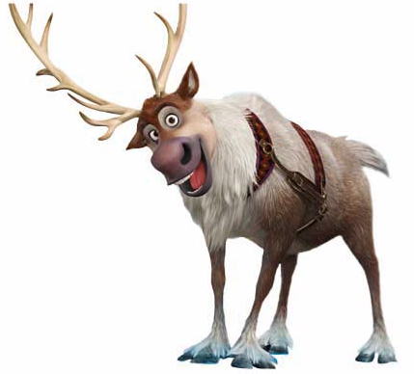 | It has a short tail.  It is grey.  It has a big body.  It is loyal to me.  It is a reindeer.  It has antlers.
white/ long/ ear/ a fish/ quiet/ feathers/ a beak/ smart/ cute / fins/ grey/ a snake/ fur/ wide wings/ a big mouth …

is와 함께 쓰인 단어들의 특징:
has와 함께 쓰인 단어들의 특징:

◆ Let me Describe my pet.
.
.
.
.

- Ask Yes/No questions about a pet and guess it!

Let’s make Yes/No questions.
yellow
antlers
black
jump
eat fish
long arms
live in water/on the ground
fly
bark
Lay eggs
tall
pretty
Speak
tail

- Is it small?

- Does it have legs?

- Can it swim?

◆ Card game: Guess the animal on a card!
1 | 2 | 3 | 4 | 5 | 6 | 7 | 8 | 9 | 10
1 | 2 | 3 | 4 | 5 | 6 | 7 | 8 | 9 | 10
1 | 2 | 3 | 4 | 5 | 6 | 7 | 8 | 9 | 10
1 | 2 | 3 | 4 | 5 | 6 | 7 | 8 | 9 | 10

